# Exercise Set#6 - Shell script understanding and exercise

**Shell scripting understanding and exercise**

The objective is to learn basic shell scripting.

**1. Shell Exercise**

**a. Write a single line command(s) which changes to a “foo” directory, command should take care that even if directory does not exist, it should create it and then change to that directory**

**Ans :**



**b. Write a single line command(s) which checks if “foo” process is running, if running then kill that process**

**Ans :**

pgrep -f "foo" && pkill -f "foo"

This command searches for the process named "foo" using pgrep. The -f option tells pgrep to match against the entire command line, not just the process name. And If the "foo" process is found, this command kills it using pkill.

**c. Write a single line command(s) which recursively searches for a “foo” file and delete it**

**Ans :**

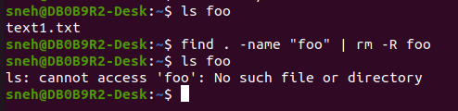

**d. Write a single line command(s) which recursively list all files in directories except for “foo” file**

**Ans :**

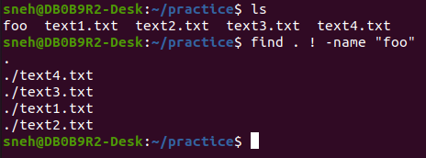

**2. Shell Script Basics**

**e. What is shell script, its purpose?**

**Ans :**

**f. Write shell scripts for following:**

**1. To add multiple numbers**

**Ans :**

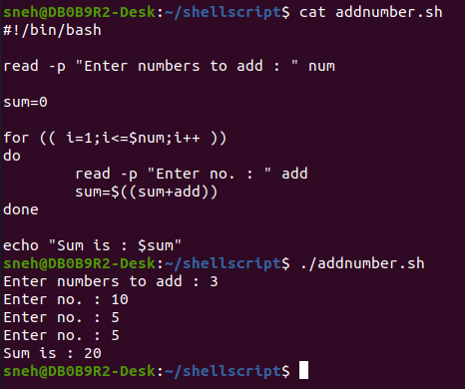

**2. Modify above script in such a way that it adds all numbers provided to it as command-line argument**

**Ans :**

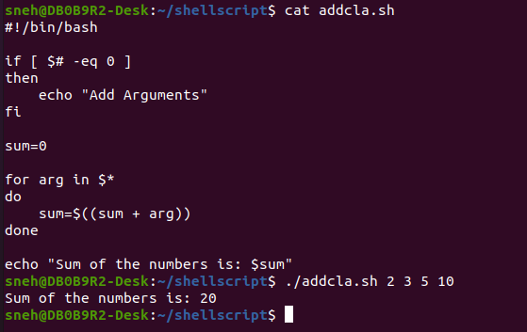

**3. The script which will,**

**3.1 Count the number of arguments to the script**

**3.2 Print all the arguments to the console**

**3.3 Print the first argument**

**Ans :**

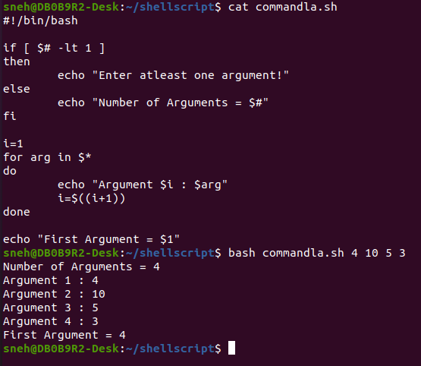

**4. Write a shell script which renames all .txt files as .text files.**

**Ans :**

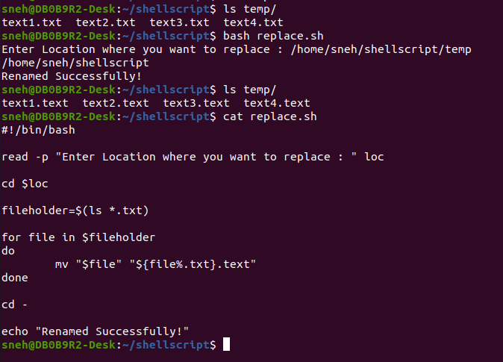

**5. To run all executable files in a directory, and provide each executables timing information**

**Ans :**

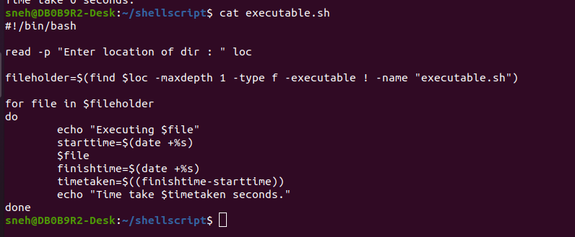

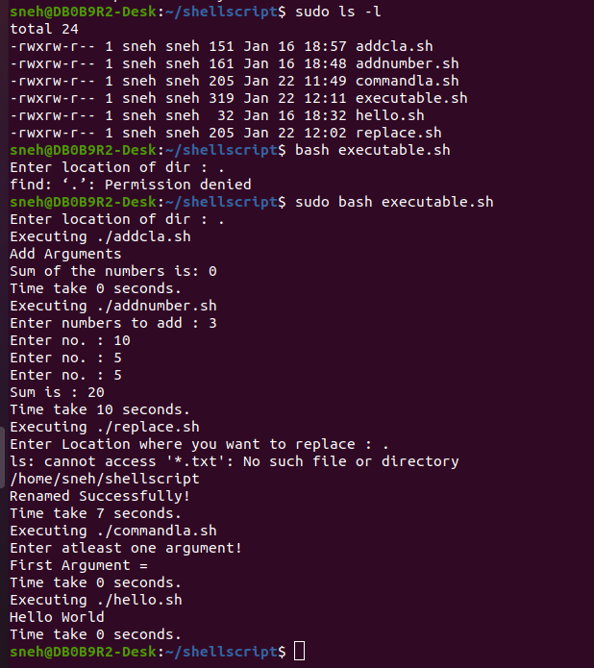

**6. Write a shell script called pidof which takes a name as parameter and returns the PID(s) of processes with that name.**

**Ans :**



